HW2 Permutations and Hanoi Towers

0616098 黃秉茂

執行結果：

Permutation：

k = 0, n = 3, with tracing step

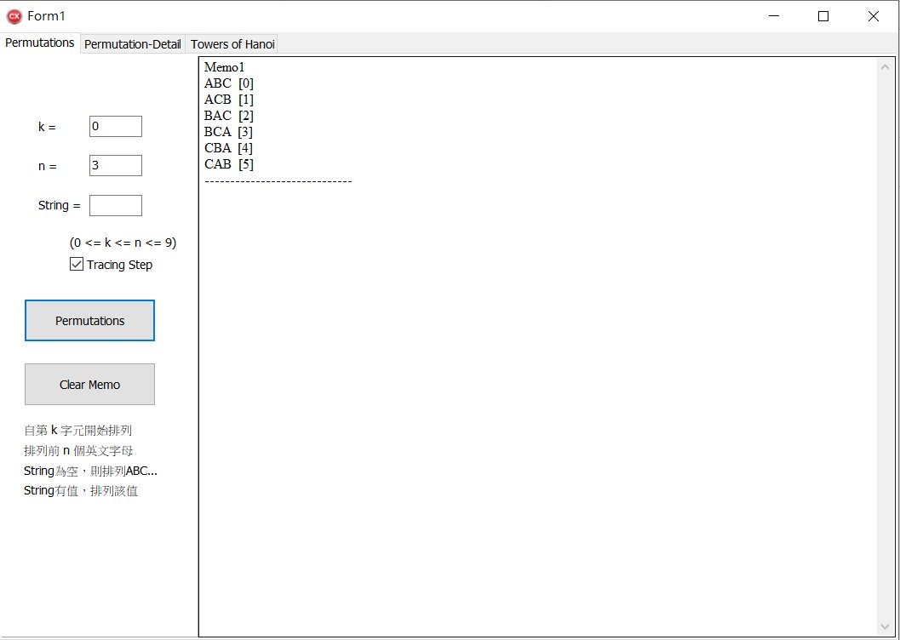

k = 2, n = 4, with tracing step

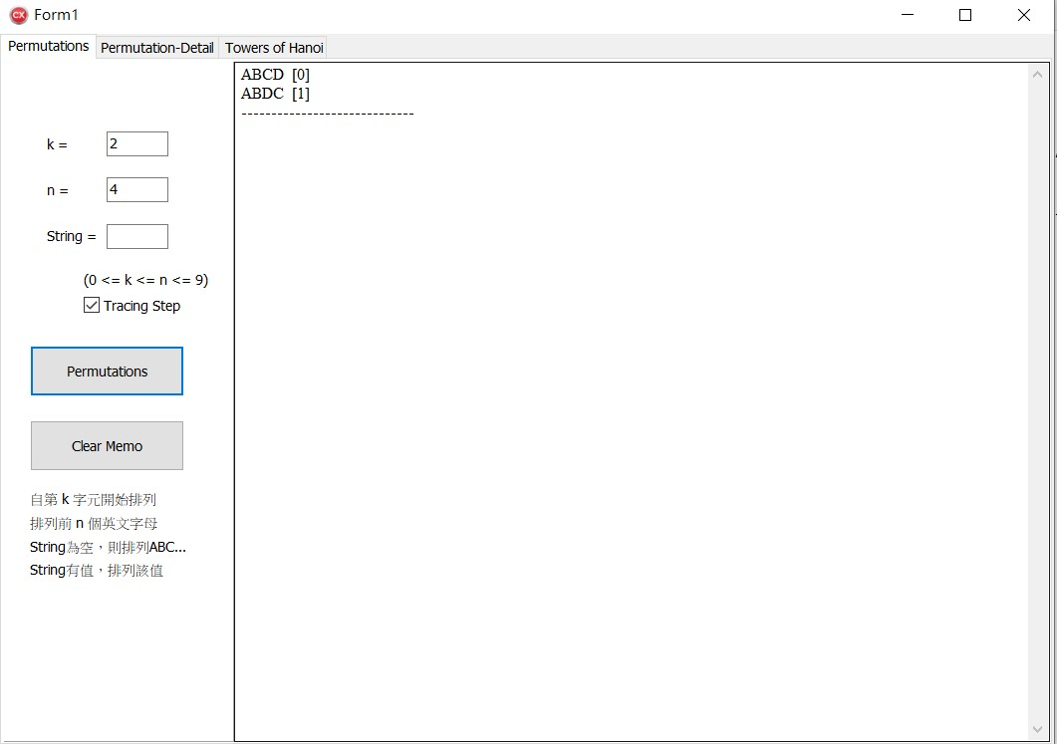

k = 0, n = 3, String =“mao”with tracing detail, permutation String(= winni) with first n(= 3) character with tracing detail

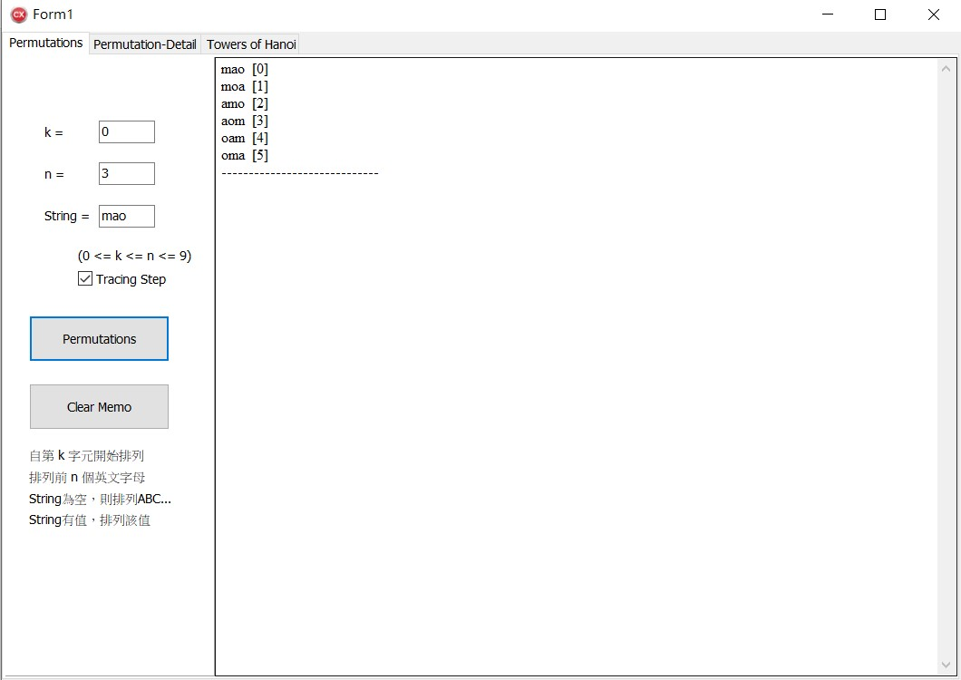

Clear memo 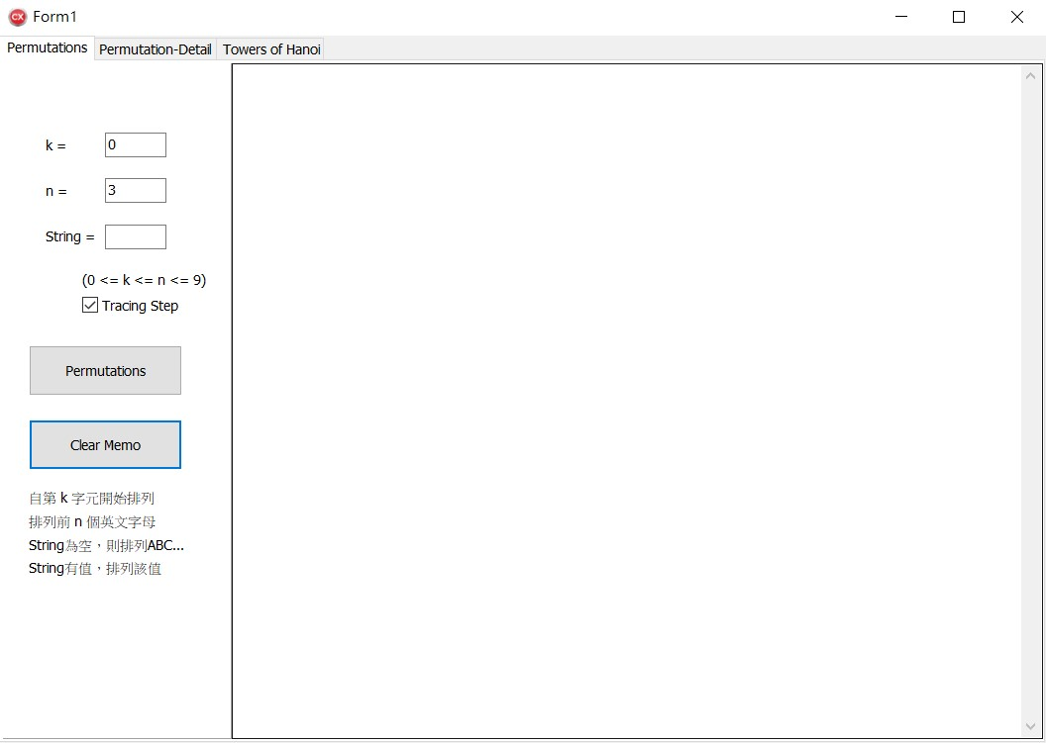

k = 0, n = 4, String =“maoimao”with tracing detail,

permutation String(= maoimao) with first n(= 4) character with

tracing detail

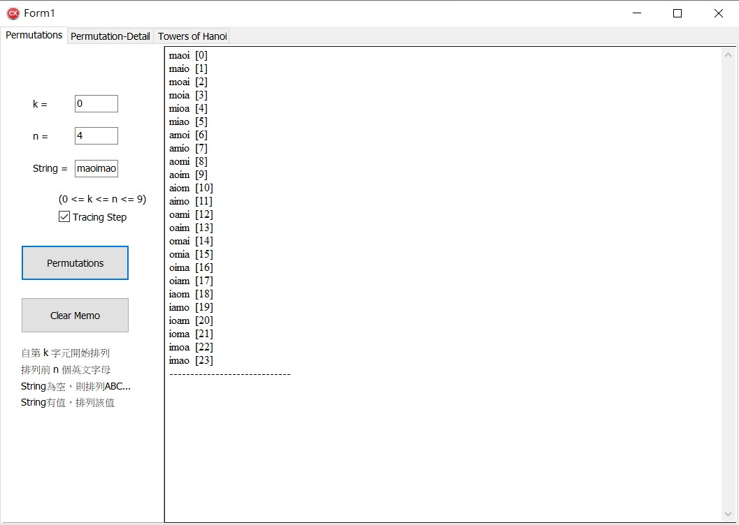

k = 1, n = 8, String =“mao”with tracing detail since

n > length of the String, permutation String(= mao) with

tracing detail

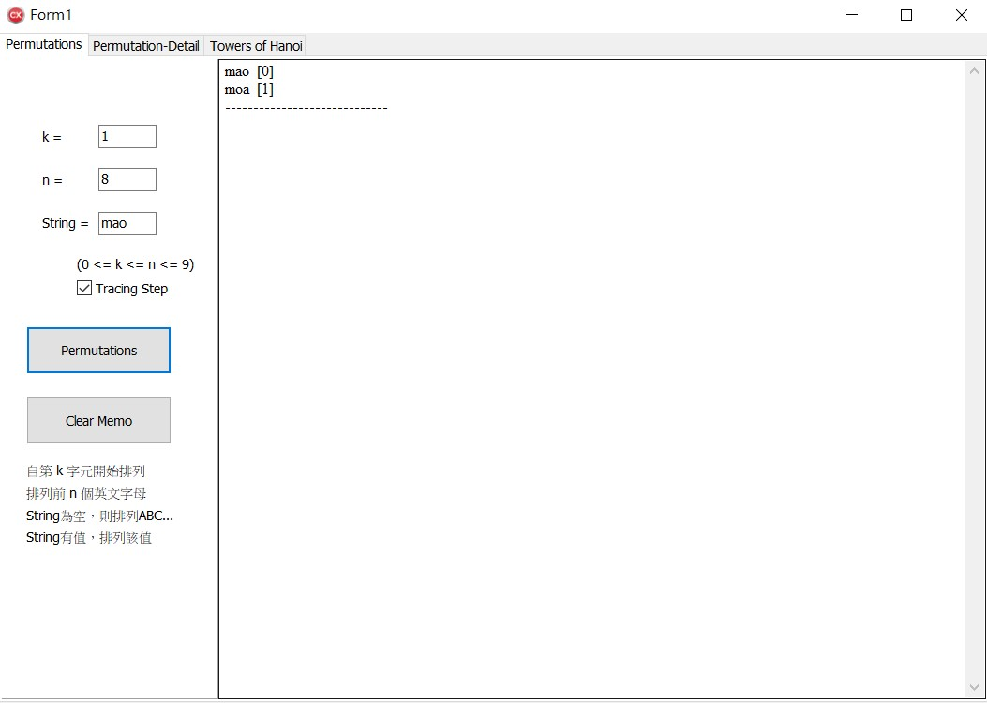

k = 1, n = 8, String =“mao”without tracing detail since

n > length of the String, permutation String(= mao) without

tracing detail

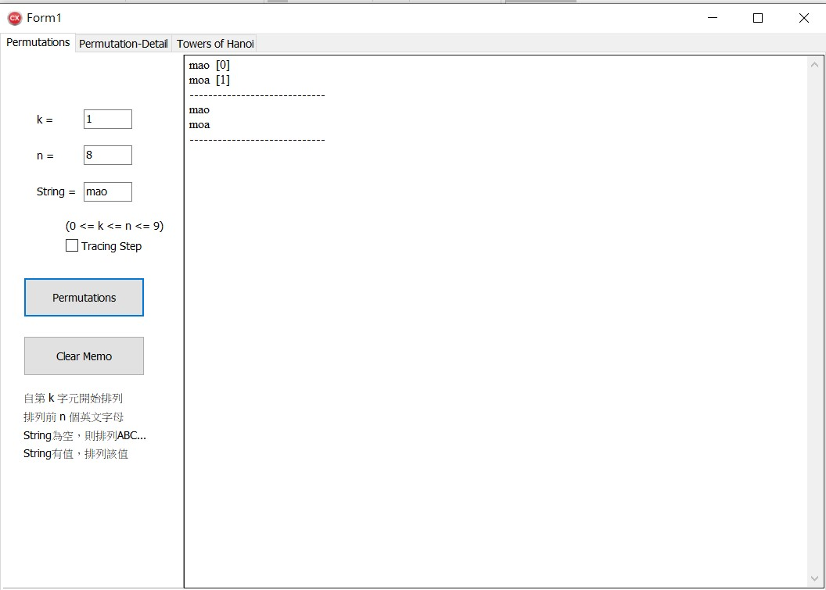

Permutation Detail：

k = 0, n = 3, without tracing detail

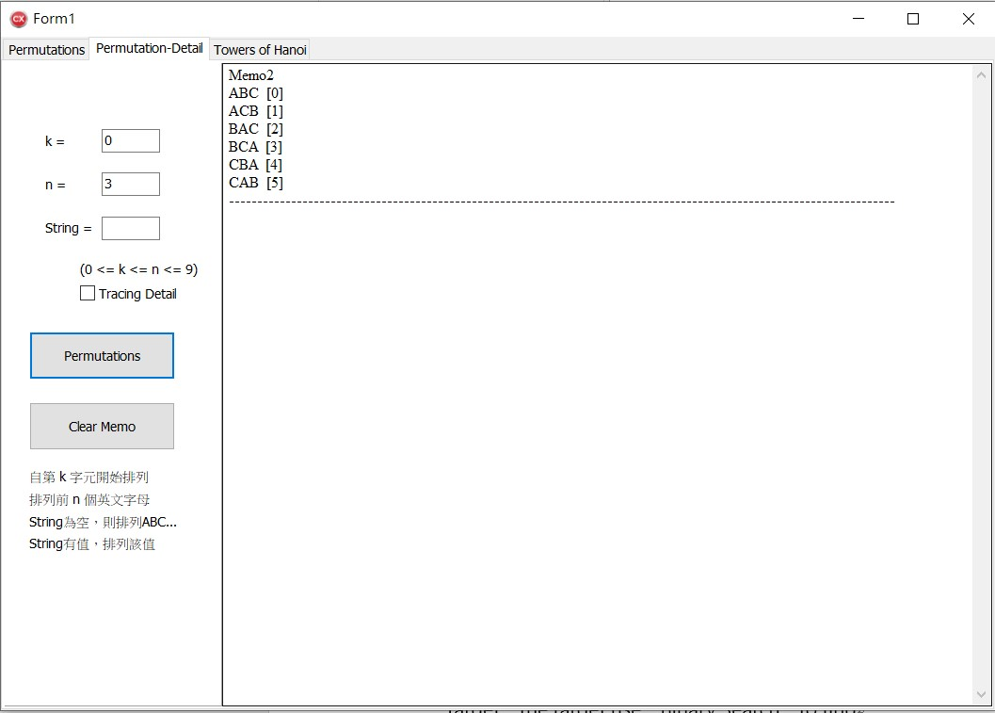

k = 0, n = 3, with tracing detail

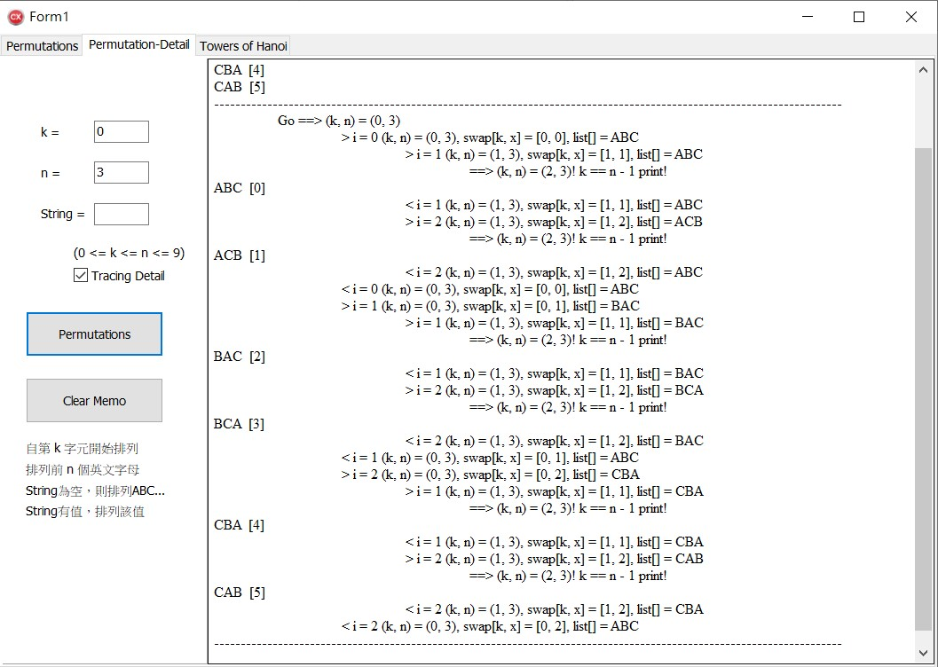

k = 2, n = 4, with tracing detail

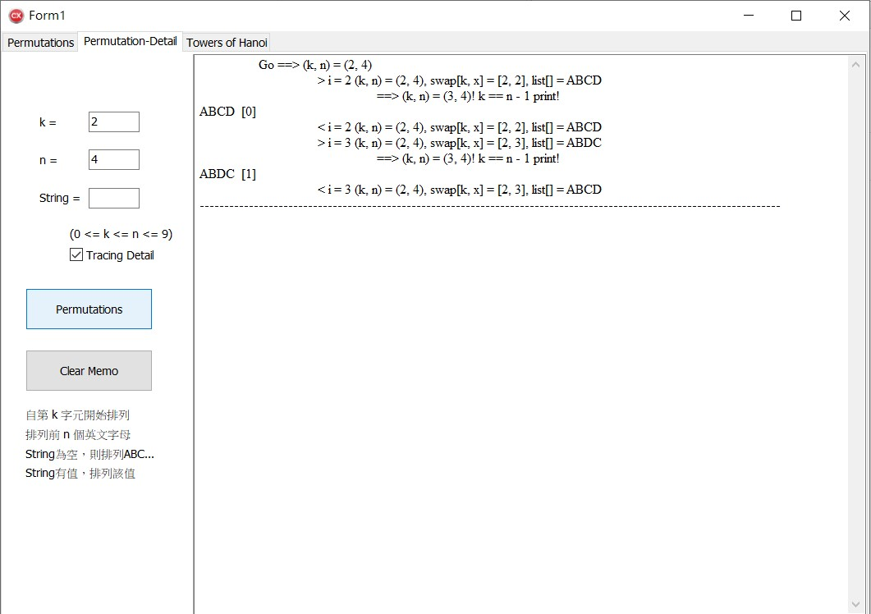

k = 0, n = 3, String =“winni”with tracing detail, permutation

String(= winni) with first n(= 3) character with tracing detail

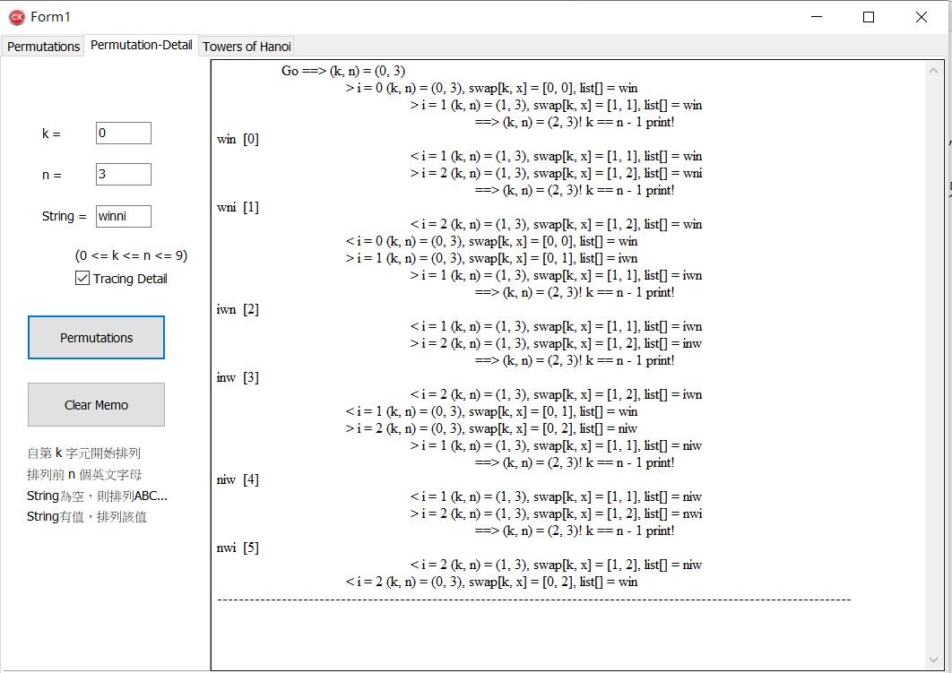

Clear memo 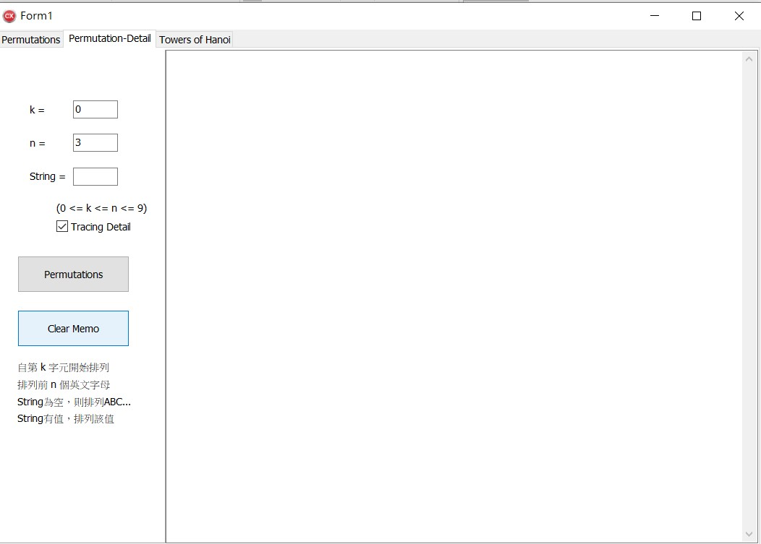

Towers of Hanoi：

n=3, without tracing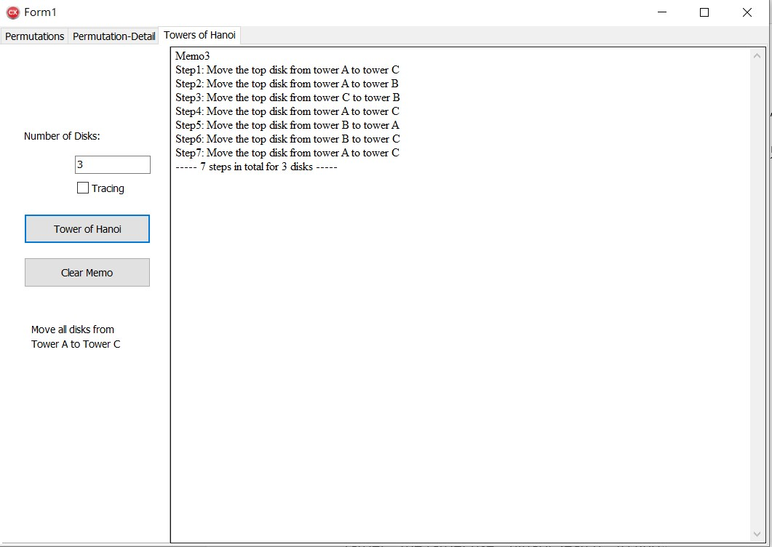

n=3, with tracing 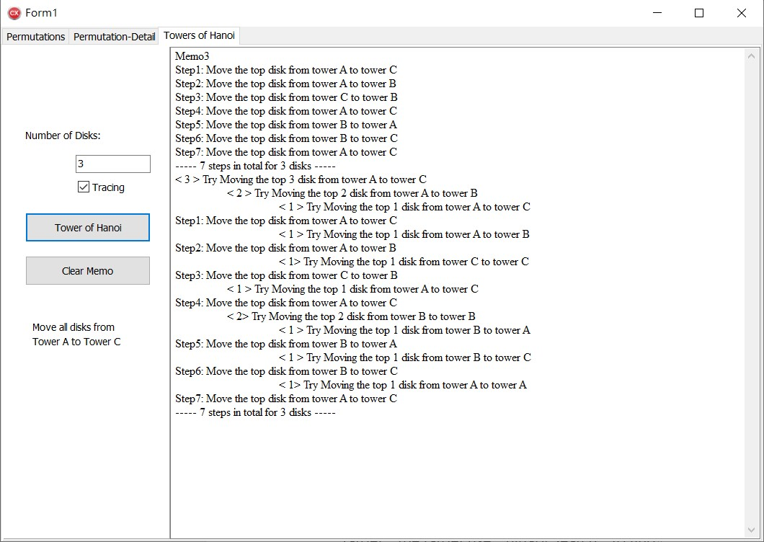

Clear memo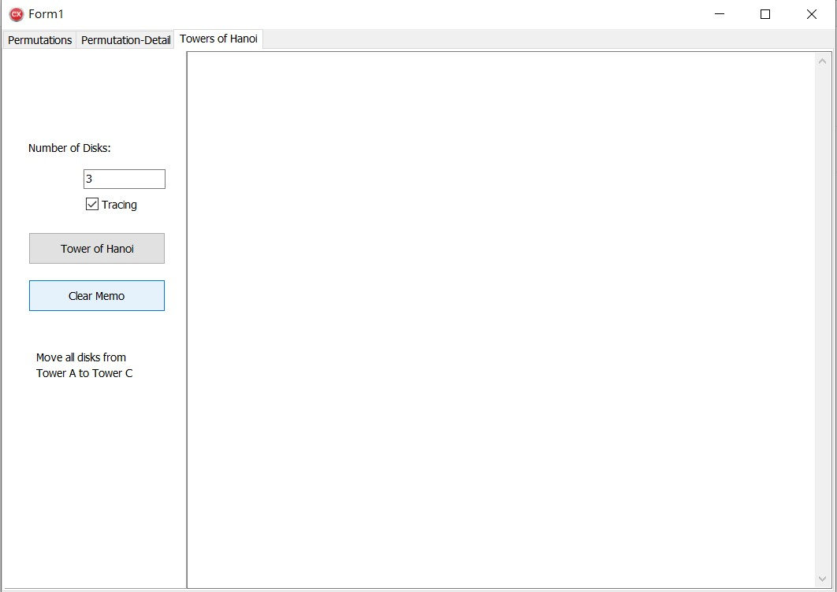

程式說明：

Permutation：

Edit：

k：自第 k 字元開始排列

n：排列前 n 個英文字母

String：String為空，則排列ABC...，String有值，排列String的該值

String有值時，當n = 0 or n > length of String，都是排列整串該String

Check-box：

Tracing Step：要不要把所有排列的順序印出來

Button：

Permutations：排列

Clear Memo：清除memo

Permutation Detail：

Edit：

k：自第 k 字元開始排列

n：排列前 n 個英文字母

String：String為空，則排列ABC...，String有值，排列String的該值

String有值時，當n = 0 or n > length of String，都是排列整串該String

Check-box：

Tracing Detail：要不要把所有排列的交換步驟印出來

Button：

Permutations：排列

Clear Memo：清除memo

Towers of Hanoi：

Edit：

Number of Disks：要疊幾片

Check-box：

Tracing：要不要印出更細節的部份

Button：

Tower of Hanoi：執行Towers of Hanoi

Clear Memo：清除memo

主要是利用recursive完成此次作業